**Enable RTL Language Support in HTML-to-PDF Conversion Using Syncfusion in .NET Core**

Syncfusion® [HTML-to-PDF converter](https://www.syncfusion.com/document-processing/pdf-framework/net/html-to-pdf) is a robust .NET library designed to convert web pages, SVG, MHTML, and HTML files to PDFs while preserving the original layout. This guide demonstrates how to enhance your PDF documents by adding right-to-left (RTL) language support, including Arabic, within the Table of Contents (TOC).

**Steps to Add RTL Language Support for TOC in HTML to PDF Conversion**

1. **Set Up Your Project**: Create a new console application project in your development environment.

2. **Install the Syncfusion Package**: Add the [Syncfusion.HtmlToPdfConverter.Net.Windows](https://www.nuget.org/packages?q=Syncfusion.HtmlToPdfConverter.Net.Windows) package from NuGet.

3. **Include Required Namespaces**: Add these namespaces in your **Program.cs**:

**C#**

|  |
| --- |
| **using** Syncfusion.Drawing;  **using** Syncfusion.HtmlConverter;  **using** Syncfusion.Pdf;  **using** Syncfusion.Pdf.Graphics;  **using** Syncfusion.Pdf.HtmlToPdf; |

4. **Implementation of Multi-Language Support**: Use the following code to integrate RTL language support into your TOC during HTML-to-PDF conversion:

**C#**

|  |
| --- |
| // Initialize the HTML to PDF converter  HtmlToPdfConverter htmlConverter = new HtmlToPdfConverter();  BlinkConverterSettings settings = new BlinkConverterSettings();  // Enable TOC and define styles  settings.EnableToc = true;  HtmlToPdfTocStyle tocstyleH1 = new HtmlToPdfTocStyle();  // Load Arabic font  PdfFont arabicFont = new PdfTrueTypeFont(@"Data/arial-unicode-ms.ttf", 10, PdfFontStyle.Regular);  tocstyleH1.Font = arabicFont;  tocstyleH1.BackgroundColor = new PdfSolidBrush(new PdfColor(Color.FromArgb(68, 114, 196)));  tocstyleH1.ForeColor = PdfBrushes.White;  tocstyleH1.Padding = new PdfPaddings(5, 5, 3, 3);  // Apply TOC styles  for (int i = 1; i <= 4; i++)  {  settings.Toc.SetItemStyle(i, tocstyleH1);  }  // Assign settings and perform conversion  htmlConverter.ConverterSettings = settings;  PdfDocument document = htmlConverter.Convert(Path.GetFullPath(@"Data/input1.html"));  // Save and close the PDF document  using (FileStream fileStream = new FileStream(Path.GetFullPath(@"Output/HTML-to-PDF.pdf"), FileMode.Create, FileAccess.ReadWrite))  {  document.Save(fileStream);  }  document.Close(true); |

A complete working sample can be downloaded from [**HTML-to-PDF-TOC-Arabic**](https://github.com/SyncfusionExamples/PDF-Examples/tree/master/HTML%20to%20PDF/Blink/HTML-to-PDF-TOC-Arabic-Text/.NET)

By executing the program, the output PDF document will be generated as shown below.

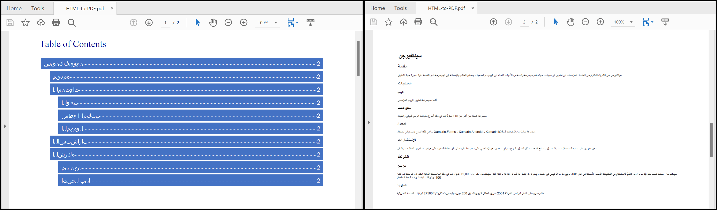

Take a moment to peruse the [**documentation**](https://help.syncfusion.com/document-processing/pdf/conversions/html-to-pdf/net/features#table-of-contents-with-custom-style), where you can find converting HTML pages to PDF document with custom style of TOC.

**Conclusion**  
I hope you enjoyed learning about how to add RTL languages when converting HTML to PDF in .NET Core.

You can refer to our [**ASP.NET Core PDF feature tour**](https://www.syncfusion.com/document-processing/pdf-framework/net-core) page to know about its other groundbreaking feature representations and [**documentation**](https://help.syncfusion.com/file-formats/pdf/create-pdf-file-in-asp-net-core), and how to quickly get started for configuration specifications. You can also explore our [**ASP.NET Core PDF example**](https://ej2.syncfusion.com/aspnetcore/PDF/Default#/bootstrap5) to understand how to create and manipulate data.

For current customers, you can check out our components from the [**License and Downloads**](https://www.syncfusion.com/sales/teamlicense) page. If you are new to Syncfusion®, you can try our 30-day [**free trial**](https://www.syncfusion.com/downloads/aspnetcore-js2) to check out our other controls.

If you have any queries or require clarifications, please let us know in the comments section below. You can also contact us through our [**support forums**](https://www.syncfusion.com/forums), [**Direct-Trac**](https://support.syncfusion.com/create), or [**feedback portal**](https://www.syncfusion.com/feedback/aspnet-core?control=pdf). We are always happy to assist you!